Postal Life Insurance

Department of Post

Software Requirements Specification (SRS)/ Functional Requirements Specification (FRS)
  - Letters & Reports- Policy

INTERNAL APPROVAL FORM

Project Name: Letters & Reports- Policy
Version: 1.0
Submitted on:
 | Name | Date
Approved By:
Reviewed By:
Prepared By:

VERSION CONTROL LOG
Version | Date | Prepared By | Remarks
1

Table of Contents

1. Executive Summary 4
2. Project Scope 4
3. Business Requirements 4
Existing Letters: 4
Existing Reports 8
4. Functional Requirements Specification 11
4.1 Create Reports Page 11
4.2 Letters Page 11
4.3 Historical Reports Page 12
5. Samples: 12

1. Executive Summary
This module is designed to automate the generation of letters and reports related to policy in the Postal Life Insurance system. It supports both event-triggered letters and manually or periodically generated reports, with standardized formatting and archival capabilities.

2. Project Scope
This module will help in understanding the requirements for letters and reports that need to be generated for the policies.

3. Business Requirements
Requirement ID | Requirement
FS_LR_001 | The system must generate specific letters based on policy lifecycle events (e.g., policy issue, premium payment, renewal, surrender, etc.).
FS_LR_002 | All letters must follow a consistent format including header, footer, font, salutation, and date/amount formatting.
FS_LR_003 | Reports should be available in both PDF and Excel formats and support adhoc generation.
FS_LR_004 | Users should be able to filter and generate reports based on different parameters like policy number, Customer ID, PAN Number, etc.
FS_LR_005 | Historical letters and reports must be stored and retrievable by users.
FS_LR_006 | The data present in reports should contain data from all sources where transaction is happening like IT 2.0, BBPS, DARPAN, etc. It should be a Unified real-time data warehouse.

Existing Letters:
List of Existing Letters:
# | Letter Name | Letter Title | Trigger Condition
1. | Surrender | Intimation/Surrender  Accepted Letter | Surrender is processed successfully
2. | Surrender | Policy Quote Value | User clicks on the Quote icon
3. | Surrender | Surrender Rejection | Approver rejects the surrender
4. | Surrender | Force Surrender Intimation | Three loan interests are not paid
5. | Surrender | Force Surrender Processed | Approver approves force surrender and surrender value is < 10000
6. | Surrender | Force Surrender Processed | Approver approves force surrender and surrender value is > 10000
7. | Surrender | Partial Withdrawal Letter | Partial surrender is processed successfully
8. | Non Forfeiture Option (NFO) | Reduced Paid Up Acceptance | Reduced Paid up is successfully processed
9. | Non Forfeiture Option (NFO) | Reduced Paid Up Rejection | Reduced Paid up is rejected by the approver
10. | Commutation | Decrease in Sum Assured/Premium Accepted Letter | Event is processed successfully
11. | Commutation | Decrease in Sum Assured/Premium Rejection Letter | Event is rejected successfully
12. | Loan | Cover Letter /Loan Sanction Letter | Loan is processed successfully
13. | Loan | Loan Rejection Letter | Loan is rejected
14. | Loan | Loan Repayment Schedule | Loan has been sanctioned
15. | Loan | Default Notice/ Overdue Intimation- Loan Capitalization Letter | Loan interest is not paid and capitalization event is triggered
16. | Loan | Cheque Dishonor for Loan  Repayment | Loan repayment cheque is dishonored
17. | Loan | Loan Closure Letter | Loan is paid completely and Loan Account is closed
18. | Loan | Loan Quote | Quote Value to be printed through the Quote screen
19. | Freelook | Freelook Cancellation Letter | Freelook is processed successfully/approved by the approver
20. | Freelook | Freelook Cancellation Rejection Letter | Freelook is rejected by the approver
21. | Cancellation | Policy Cancellation Acceptance Letter | Policy cancellation request is approved
22. | Cancellation | Policy Cancellation Rejection Letter | Approver rejects the policy cancellation request
23. | Conversion | Conversion Acceptance Letter | Conversion request is approved
24. | Conversion | Conversion Rejection Letter | Conversion request is rejected
25. | Fund Switch | Fund Switch Letter acceptance | Funds are switched successfully
26. | Fund Switch | Fund Switch Rejection Letter | Approver rejects Fund Switch
27. | Redirection | Redirection Acceptance Letter | Future redirection of funds to be effected
28. | Redirection | Redirection Rejection Letter | Approver rejects the redirection request
29. | Billing and Collection | Premium Due Notice | - Renewal reminder letter will be generated based on Frequency, specific days before the bill to-date.  - Status of policies will not be generated for monthly frequency policy
30. | Billing and Collection | List Bill Due Notice | - List bill will be populated in the employer portal by 15th of every month  - Standard letter to be sent by 10th every month  - The bill details are populated in the employer portal that can be accessed only by the employer  - Reminder must be sent on 7th of the next month if premium is not received
31. | Billing and Collection | List Bill Due Reminder | Reminder must be sent on 7th of the next month to the employer if premium is not received
32. | Billing and Collection | Payment Failure/ Cheque Bounce Letter | Cheque bounce details are received from the bank
33. | Nomination Letter | Nomination Letter | Will be generated when nomination is approved
34. | Assignment Letter | Absolute Assignment Letter | Successful processing of the absolute assignment
35. | Assignment Letter | Conditional Assignment Letter | Successful processing of conditional assignment
36. | Assignment Letter | Assignment Rejection Letter | Assignment request is rejected
37. | Death Claim | Notification Letter | Claim is notified
38. | Death Claim | Settlement Letter | Claim is successfully processed  Note: In this case, the letter will be sent to the Payee by the user. If the Payee is not mentioned in the letter, it needs to pick up the nominees name and address
39. | Death Claim | Discharge Voucher | Sent as part of claim settlement letter
40. | Policy Servicing | Name Change | Name in the policy is changed
41. | Policy Servicing | Address Change | Address in the policy is changed
42. | Reinstatement | Revival /Reinstatement Letter | Lapsed policy is revived successfully and the Approver approves the revival/reinstatement request
43. | Reinstatement | Reinstatement Rejection Letter | When revival/reinstatement is rejected
44. | Reinstatement | Void Status Letter | Policy status is changed to Void
45. | NBF and Policy Service | Letter to Customer/Agent for Missing Requirement | Missing/additional documents are required
46. | NBF and Policy Service | Non-receipt Letter to customer/Agent for Missing Requirement | Non-receipt of missing/additional documents after 15 days of issue of first letter
47. | NBF | Letter to Customer for Premium Change | Sent before policy issuance in case premium changes (counter offer)
48. | NBF | Letter to Customer for Proposal Rejection | Proposal is declined
49. | Reinstatement | Lapse Letter | Policy is Lapsed
50. | Survival Benefit | Survival Benefit Notification Letter | Survival benefit is due for a policy
51. | Survival Benefit | Survival Benefit Settlement Letter | Survival benefit is approved for a policy
52. | Survival Benefit | Survival Benefit Settlement Rejection Letter | Survival benefit is rejected for a policy
53. | Billing and Collection | Electronic Fund Transfer (EFT) Transaction Unsuccessful | EFT Transaction is not successfully processed due to any reasons
54. | Death Claim | Death Claim Rejection | Death claim has been rejected
55. | Policy Servicing | Premium Payment Method Change | Method has been changed successfully
56. | Policy Servicing | Premium Payment Method Change Rejected | Approver rejects the request
57. | Maturity Claim | Maturity Claim Notification Letter | Policy reaches its maturity
58. | Maturity Claim | Maturity Calculation Sheet and Settlement Letter | Maturity claim is approved by the approver
59. | Maturity Claim | Maturity Claim Rejection Letter | Maturity claim is rejected by the approver
60. | Surrender | Surrender Withdrawal- Approval | Approver approves withdrawal
61. | Surrender | Surrender Withdrawal- Rejection | Approver rejects withdrawal

Elements Common across Letters
# | Type of Information | Information
1 | Header | This section displays the logo and the return address.
2 | Footer | This section displays the respective Central Processing Center (CPC) address and contact details.
3 | Date Format | In top left corner, the date lines up with the company name under the logo and return address. Format of date is DD/MM/YYYY. For example, 18/03/2012. The same date format is used in the body of letter.
4 | Amount Format | Amount starts with the Rs. Symbol and a comma is added after thousand. The amount is always up to two decimal places. For example, Rs.2,54,000.00
5 | Closing Paragraph | The following standard closing paragraph is used wherever applicable: If you have any questions, please contact your Representative or our Head Office Member Services Department at <CSR Contact Number>.  - If you have any questions, please contact your Representative or our Head Office Member Services Department at 1-800-000-0000.  Enclosures: If any Signature 1: For the post issue letters -Yours faithfully, Member Services India Post
6 | Font | All letters are in Arial font style with font size 10.
7 | Heading | This displays the Letter Title.
8 | Salutation | This includes name of the Person to whom letter is being sent. For example, salutation implies Dear Mr./Ms./Mrs.

Existing Reports
Report Types:
- Periodic Reports: These reports are automatically generated daily, weekly, monthly, half-yearly or yearly.
- Adhoc Reports: These reports are generated manually as and when required.
- MIS Reports: The application allows users to process various types of reports. Some of these reports are used by the higher management to take important decisions. These reports are called the Management Information System (MIS) reports.
List of Existing Reports
# | Report Category | Report Title | Frequency
1 | New Business | New Policies Procured | Daily
2 | Cancellation | Cancelled Transactions | Monthly
3 | Billing and Collection | NACH-billing method change | Monthly HO wise
4 | DARPAN | DARPAN Category wise Txns report | Daily
5 | Policy | Circle wise Active and Inactive policies as on 1st date of Month | Monthly
6 | Policy | Division wise Active and Lapsed Policies as on 1st date of the month | Monthly
7 | Policy | HO wise No. of policies with Aadhar/ Mobile/e-mail updation Monthly | Monthly
8 | Customer Portal | Customer Portal Day End collection report | Daily
9 | Billing and Collection | Pending Renewal Report | Daily and Monthly
10 | Loan | Loan installment arrears Report | Monthly/Quarterly/Semi-annually/Yearly
11 | Loan | Loan Interest Recovered Report | Monthly/Quarterly/Semi-annually/Yearly
12 | Claim | Death Claim Report | Monthly/Quarterly/Semi-annually/Yearly
13 | Claim, Surrender | Full Surrender Report, Death Claim Report, Maturity Claim Report | Monthly/Quarterly/Semi-annually/Yearly
14 | Claim | Product Wise Claim Paid Report | Monthly/Quarterly/Semi-annually/Yearly
15 | Accounts and Actuary | Calculation of  Incurred But Not  Reported (IBNR)  for Accounts  Department and  Appointed Actuary | Adhoc
16 | Claim | Claim Ratio Report | Monthly
17 | Claim | Claim Report on earned premium | Daily
18 | Claim | Death Claim Pending Report | As frequency could be varied, date range would help user to pull the report as per the requirement
19 | Claim | Average Claims per Policy Report | Adhoc
20 | Disbursement | Disbursement through NEFT Report | Adhoc
21 | Claim | Claims Distribution Channel Wise | Monthly/Quarterly/Semi-annually/Yearly
22 | Profitability | Product Portfolio Report | Adhoc
23 | Profitability | Profitability Analysis Report | Yearly
24 | Profitability | Risk Analysis Report | Monthly
25 | New Product | Key Features of product for filing new product | Anytime /Adhoc
26 | Profitability | Business Projection for Next Five Financial Years | Adhoc
27 | Profitability | Investment Performance Report | Daily
28 | Billing and Collection | Daily Premium Realization Report | Daily
29 | Billing and Collection | Cheque Bounce Report | Daily
30 | Billing and Collection | Premium Realization Report | Daily, Date Range Given
31 | Billing and Collection | Advance Premium  Realization Report | Daily, Date Range Given
32 | Profitability | Branch Product Portfolio Report | Adhoc
33 | Profitability | Key Parameters Report | Adhoc
34 | Turn Around  Time (TAT) | Grievance Turn Around Time Report | Daily
35 | Turn Around Time (TAT) | Grievance Analysis Report | Daily
36 | Profitability | Portfolio Profitability Report | Yearly
37 | Claim | Claim Register Report | Daily/Monthly/Quarterly/Semi annually/Yearly
MIS Reports
38 | New Business | New Business in Forced Report | Daily/ Weekly/ Monthly/ Quarterly/ Semi-annually/Yearly
39 | DARPAN | DARPAN MIS- upto BO level | Daily
40 | Billing and Collection | Daily Premium Collection Report Daily Cheque Realization Report | Daily
41 | New Business | Policy pending Enforcement Report | Daily
42 | Claim | Report - Claims Logged | Daily
43 | Claim | Report - Claims Settled Death Report - Claims Settled Maturity | Daily/ Weekly/ Monthly/ Quarterly/ Semi-annually/Yearly
44 | Loan | Report - Loan Disbursed | Daily/ Weekly/ Monthly/ Quarterly/ Semi-annually/Yearly
45 | Assignment | Report - Policy Assignment- Absolute Report - Policy Assignment- Conditional | Monthly/ Quarterly/ Semi-annually/Yearly
46 | Billing and Collection | Premium Accountability | Daily/ Weekly/ Monthly/ Quarterly/ Semi-annually/Yearly
47 | Lapsation | Report - Lapse Events | Daily/ Weekly/ Monthly/ Quarterly/ Semi-annually/Yearly
48 | Surrender | Report - Full Surrender Report - Partial Surrender | Daily/ Weekly/ Monthly/ Quarterly/  Semi-annually/Yearly
49 | Reinsurance | Report - Policy Reinsurance | Daily/ Weekly/ Monthly/ Quarterly/ Semi-annually/Yearly
50 | Unit Linked Insurance Policy (ULIP) | Report -Fund Details | Daily
51 | Billing and Collection | Premium and Documentation Received Report | Daily
52 | Conversion | Report - Policy Conversion | Monthly
53 | TAT | Report -TAT (Turn  Around time) | Monthly
54 | New Business | BO Level Classification of New Business | Adhoc
55 | New Business | Reason Wise Freelook Cancellation Report | Adhoc
56 | New Business | Policy Cancellation Report | Adhoc

Elements Common across Reports
# | Type of Information | Information
1 | Company Name | This section displays the text Postal Life Insurance and logo.
2 | Header | This section contains the following information:  - Report Name  - Process Date: - <report start date> - <report end date>
3 | Footer | This section contains the following elements:  - < Current Date/time> left justified along the bottom  - Page <page number> of < number of pages> right justified along the bottom

4. Functional Requirements Specification

4.1 Create Reports Page
Clicking ‘Create Reports’ button should open this page. This page allows users to generate reports using filters.

- Fields:
  - Report Type: Dropdown (PDF, Excel).
  - Policy Number: Text: Option to search & select policy should be present.
  - Customer ID: Text: Option to search & select Customer should be present.
  - Report Start Date / End Date: Calendar fields.
  - Office Type / Location: Dropdowns.
  - Generate Report: Button to initiate report generation.

4.2 Letters Page
This page stores and displays all letters generated by the agent.
- Fields:
  - Search Bar: Text input to search by Agent Name or Agent ID
  - Letter Type Filter: Dropdown (e.g., Welcome, Appointment, Termination)
  - Date Range: Two calendar fields (Start Date, End Date)
  - Policy Number: Text: Option to search & select policy should be present.
  - Customer ID: Text: Option to search & select Customer should be present.
  - Letter Type: Display column
  - Generated Date: Display column
  - View Letter: Button/icon to open/download the letter
  - Download Format: Option to download as PDF
  - Pagination Controls: For navigating through records

4.3 Historical Reports Page
This page stores and displays all reports generated by the user. It should be limited to last 10 generated Reports by the respective user.

- Fields:
  - Search Bar: Text input to search by Report Title
  - Report Category Filter: Dropdown
  - Date Range: Two calendar fields (Start Date, End Date)
  - Report Title: Display column
  - Report Category: Display column
  - Generated Date: Display column
  - Format: Display column (PDF/Excel)
  - View Report: Button/icon to open/download the report
  - Pagination Controls: For navigating through records

5. Samples:
Existing Core Insurance Solution reports available at utilities portal of PLI:-
- Daily Report -New Policies Procured :

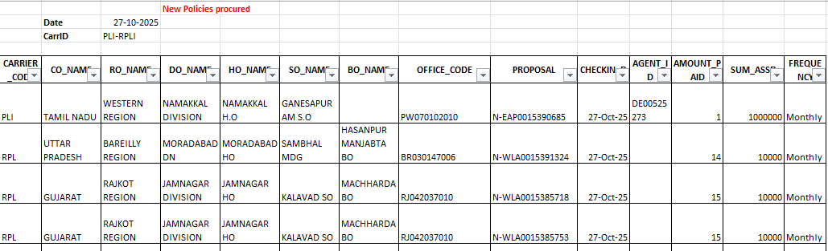
- Cancelled Transactions-Monthly report : 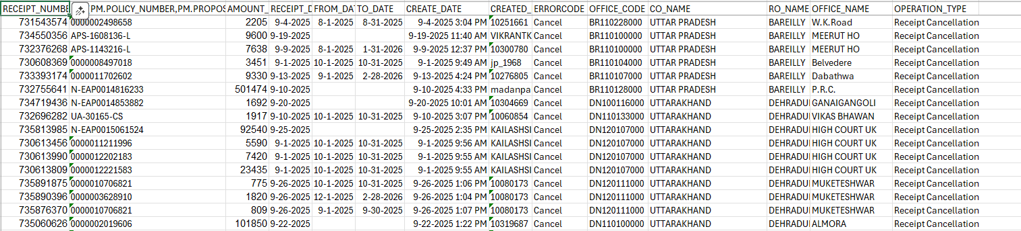

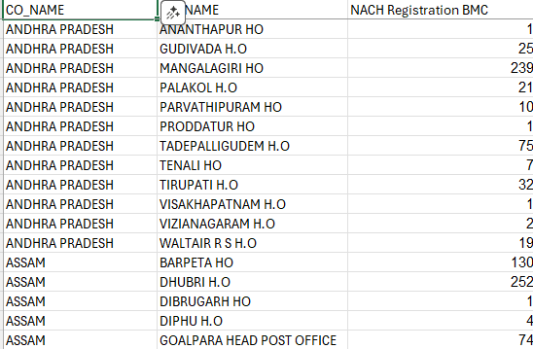
- NACH-billing method change-Monthly HO wise :

- DARPAN MIS- upto BO level :
- DARPAN Category wise Txns report :

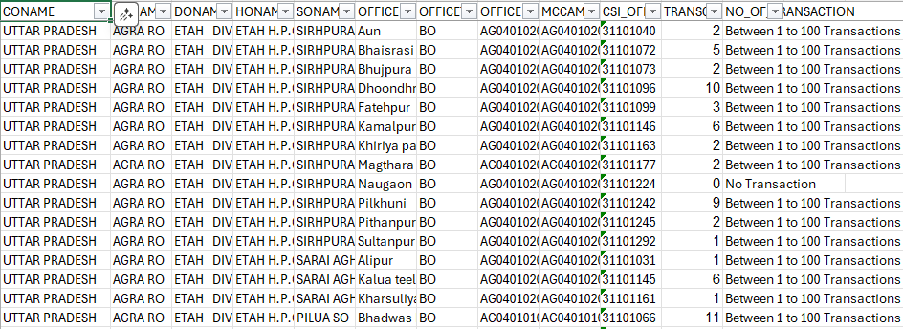

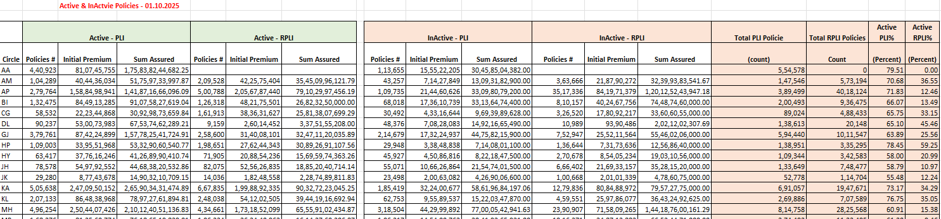
- Circle wise Active and Inactive policies as on 1st date of Month:

- Division wise Active and Lapsed Policies as on 1st date of the month:
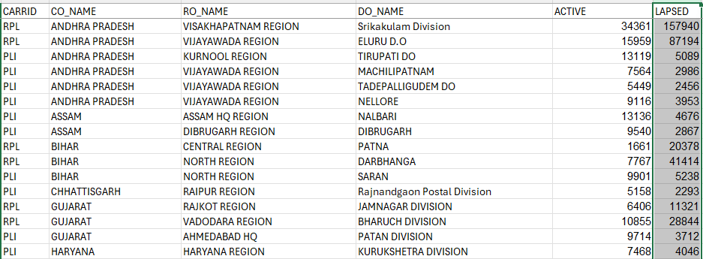

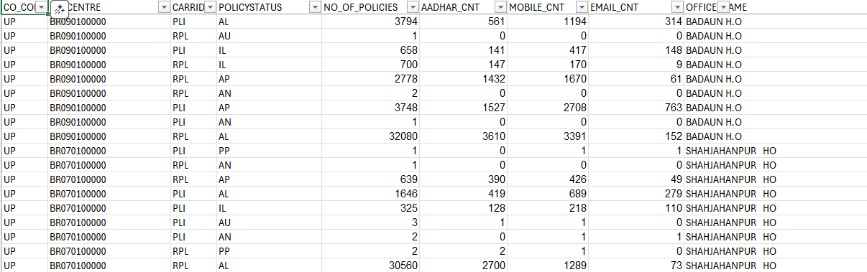
- HO wise No. of policies with Aadhar/ Mobile/e-mail updation Monthly:

- Reports available through front end McCamish:-
- The existing reports available at McCamish in two types i.e. detailed and consolidated
- In PDF and Excel format
- Access of report given hierarchy wise Circle-Region-Division
- Screenshot of Reports module available in McCamish is attached herewith:
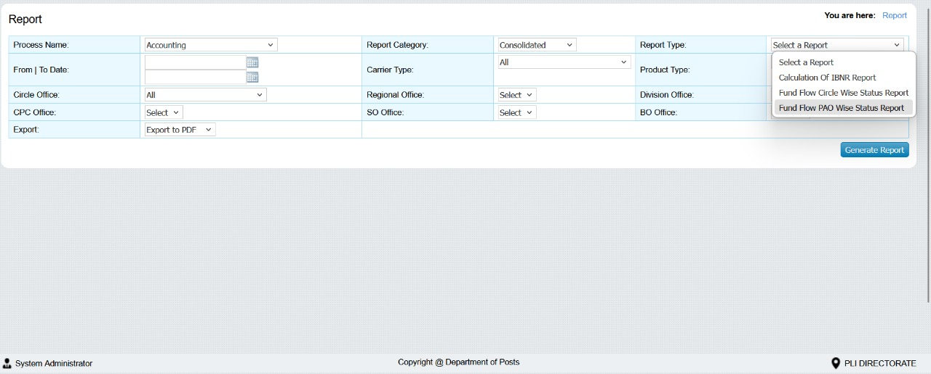
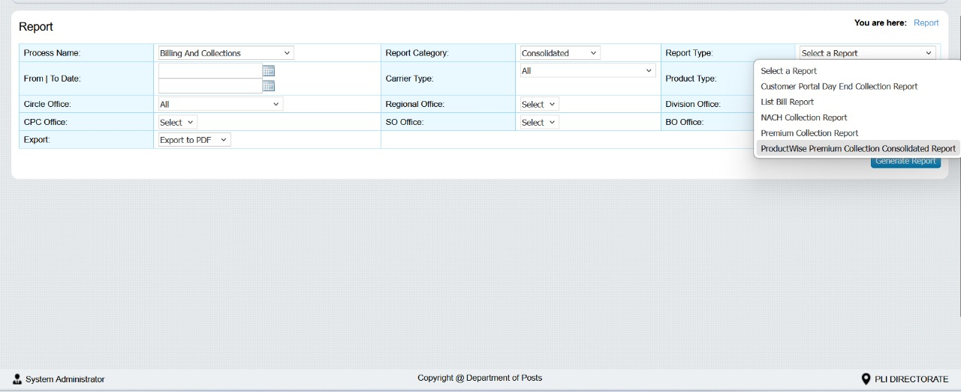
Customer Portal Day End collection report:

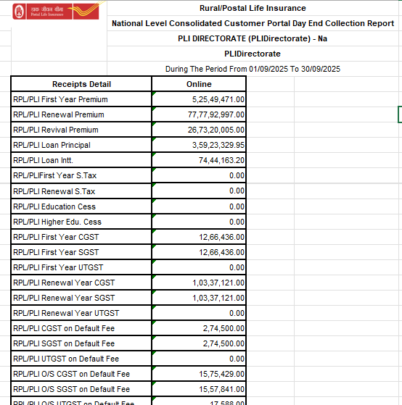

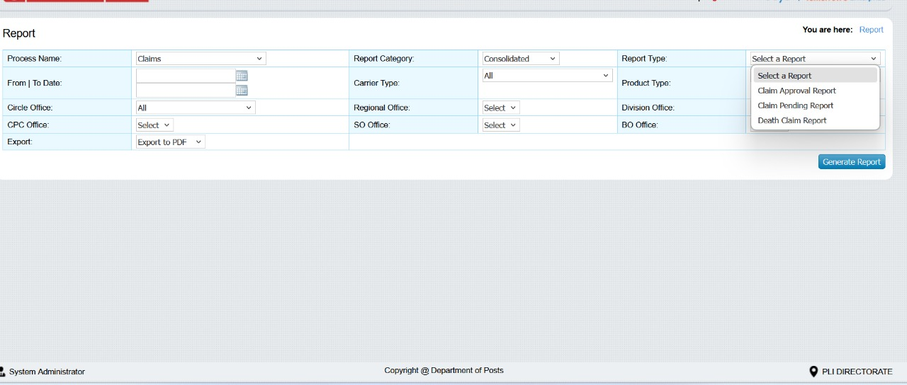

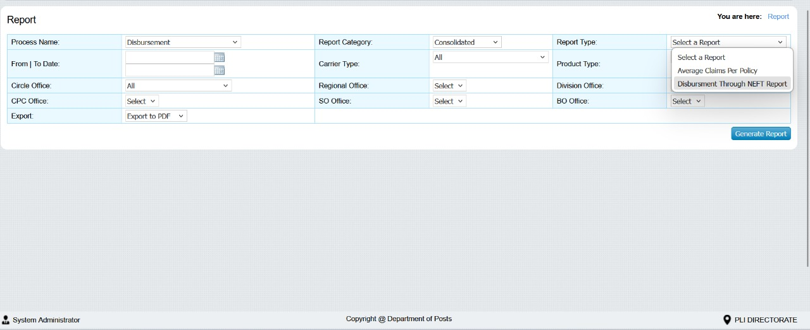
Average Claims per Policy report : 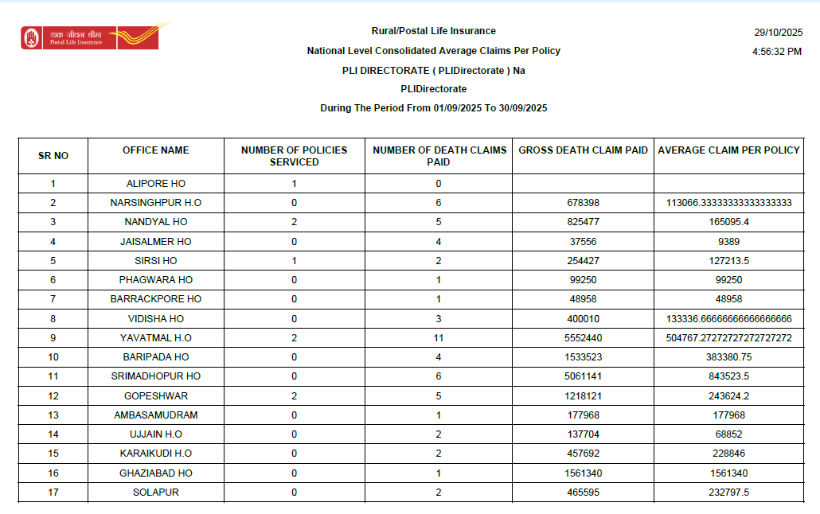

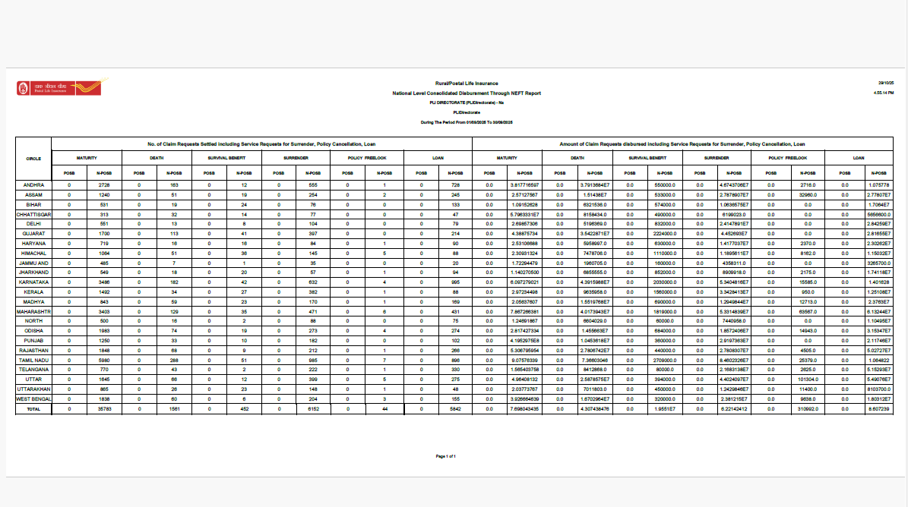
Consolidated Disbursement through NEFT Monthly Circle wise:

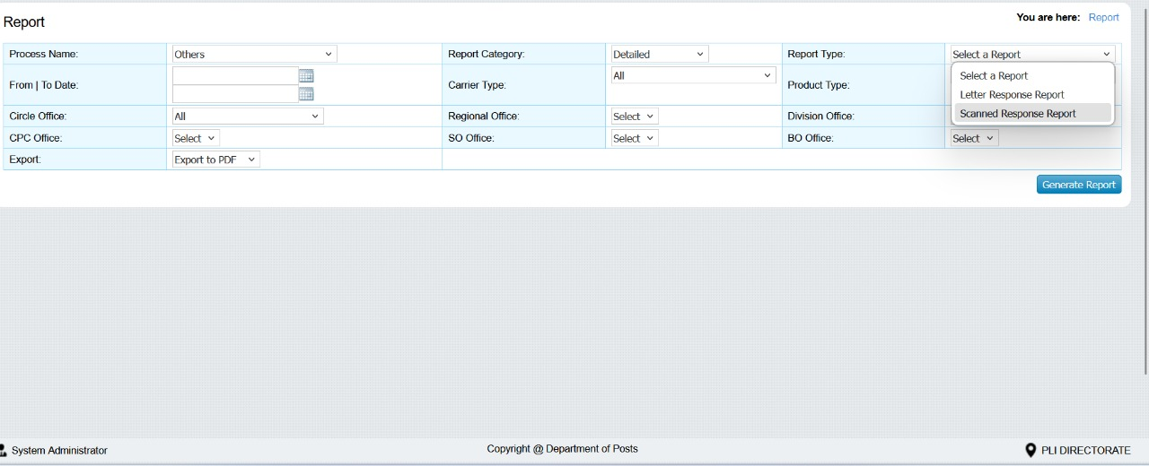

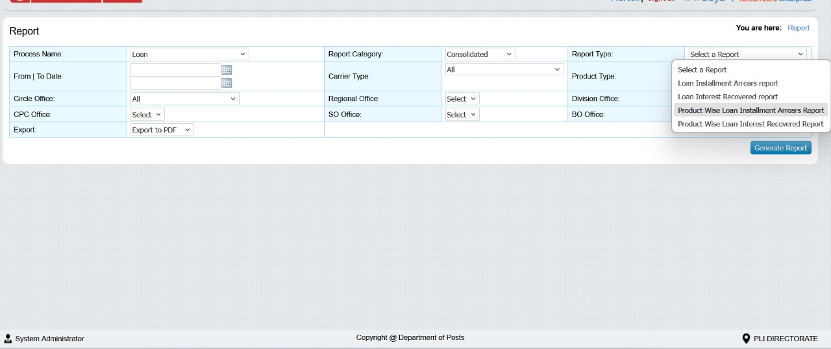

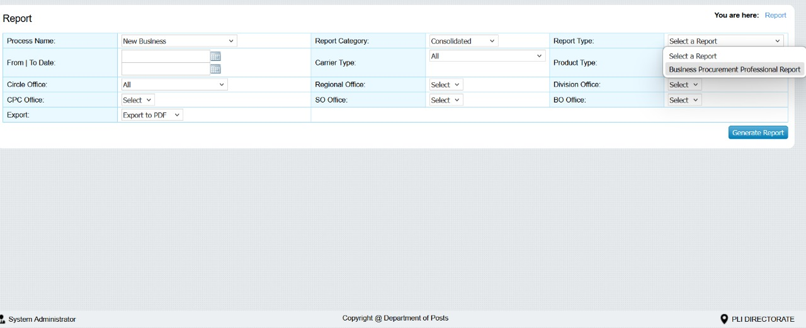

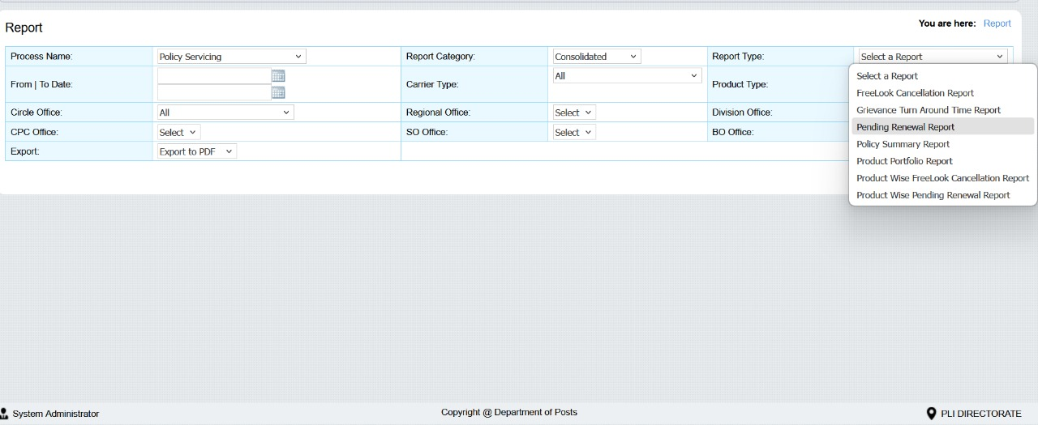

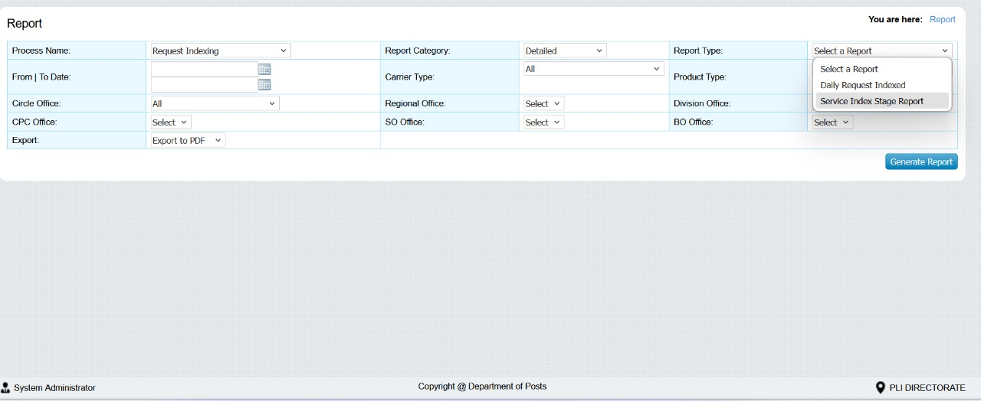
Reports available-Adhoc Scheduling:
